Backward Design Worksheet
Course Goals

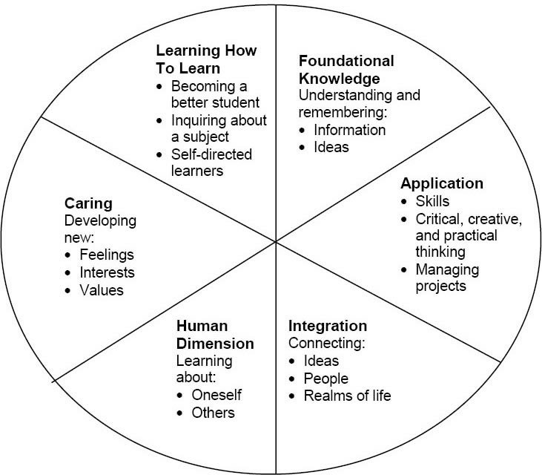

Draft Your Goals:
Write 2-3 course goals for your dream course using Fink's taxonomy. Incorporate the categories you found most meaningful.

Learning Outcomes
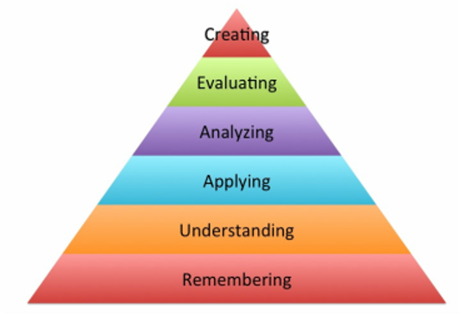
Remember​ | Understand​ | Apply​ | Analyze​ | Evaluate​ | Create​
Define​ | Classify​ | Demonstrate​ | Contrast​ | Arrange​ | Assemble​
Duplicate​ | Describe​ | Employ​ | Criticize​ | Assemble​ | Construct​
List​ | Explain​ | Illustrate​ | Debate​ | Collect​ | Create​
Memorize​ | Express​ | Interpret​ | Distinguish​ | Conclude​ | Design​
Recall​ | Identify​ | Operate​ | Examine​ | Determine​ | Develop​
Repeat​ | Recognize​ | Sketch​ | Question​ | Diagnose​ | Formulate​
Reproduce​ | Report​ | Solve​ | Test​ | Differentiate​ | Write

Please select ONE of your Fink-based course goals. Write 2-3 learning outcomes using Bloom's action verbs on your worksheet.​

Assignments
Choose one of your learning outcomes​, generate as many potential aligned assignment ideas as you can for this outcome​

Content
What methods will you use to structure your course?​

Teaching Strategies
What teaching strategies will help your students succeed?

