Cues and Clues to Diagnose Critical Points of Intersection between the capacities of AI and the learning goals/needs of students
This handout contains strategies for considering how your course intersects with generative artificial intelligence intersects including the learning goals of your course and needs of your students.

AI Capacities (common practices) and Initial Responses
As you begin the process of evaluating your course and consider broadly the capacities of AI. Below is a list of some of the most common current uses of AI tools by students. Based on your knowledge of your course, indicate your initial reaction to the impact that each application of AI is likely to have on students' learning:
This is awesome! This will help students!
Oh no! If students do this, they will not learn what they need!
Hmm, it's complicated. There are definitely some pros and some cons.
I don't know. I need to learn more about how this works.

AI Capacity | Capsule Definition | Your Take
Summarizing text | AI can provide interpretive summaries of complicated text
Definitions | AI can provide quick definitions of terms and concepts
Prose composition | AI can generate text of various length
Grammar checking | AI can proof-read text and suggest grammatical changes
Citation generation | AI can provide formatted citations
Academic assistance | AI can provide explanations of concepts and methods
Translation | AI can translate text between or conduct conversations in several languages
Project planning | AI can generate lists of suggestions and alternatives
Exam preparation | AI can generate quizzes and questions about material

Conduct a Detailed Survey of Your Course in Light of AI
This section consists of a set of prompts to direct your attention to standard elements and aspects of the student experience of your course that AI's capacities are most likely to impact, as well as to begin thinking about what kind of action might thus be called for on your part.
For each of the points below, it can be helpful to think in terms of playing defense and playing offense:
- Playing defense means considering uses you may want to discourage: ways that student use of AI may undermine their learning or constitute academic misconduct
- Playing offense means looking for uses you may want to encourage and support: opportunities where AI use can enhance student learning or make new levels or kinds of learning possible

Learning Goals
Copy/paste the learning goals and ELOs from your syllabus in the table below. With each goal and outcomem, refresh your clarity about what students need to learn. We recommend using the modified framework of Bloom's taxonomy developed by Anderson & Kratwohl (illustrated below) because it asks you to consider not only the domain of learning (remembering, understanding, etc.) but also the level(s) at which students need to perform in that dimension (knowing facts, understanding concepts, etc.). Precision about what students need to do will help us better anticipate how AI is likely to impact student learning.
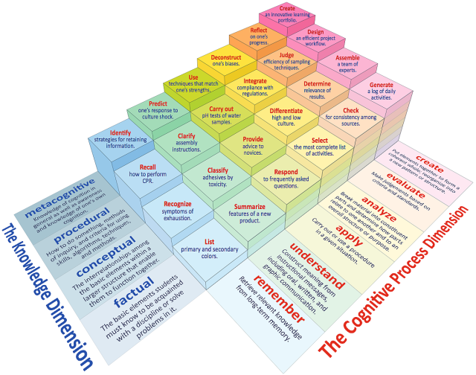
In addition, it is useful to consider questions about whether or students need to demonstrate their learning without assistance.
- Do students need to be able to demonstrate this ability autonomously?
- Do students need to be able to demonstrate all aspects of this ability autonomously?
As students acquire this ability, are there moments when AI might provide meaningful temporary assistance?

Goal | Learning Outcomes | Cognitive Dimension: domain  (remember, apply, etc.) | Knowledge Dimension: level  (factual, conceptual, etc.)
Notes on Implications of AI:

Notes on Implications of AI:

Notes on Implications of AI:

Notes on Implications of AI:

Activities and Assignments [Blooms-based diagnostic loop]
Go through the assignments students complete in your course. For each assignment and activity (or type of assignment/activity, if it is a routine), consider whether student use of AI would impact student learning, either in ways you might want to defend against or in ways that you might want to encourage.
Summative assessments | Defense | Offense
Additional notes

Formative assessments | Defense | Offense
Additional notes

Practice | Defense | Offense
Additional notes

Reading and watching | Defense | Offense
Additional notes

Interaction & Collaboration | Defense | Offense
Additional notes

Other | Defense | Offense
Additional notes

Checklist of Typical Teaching Forms
AI is likely to affect different modes of teaching and learning in different ways. For each of the forms below that you incorporate in your teaching, take a moment to consider how AI may impact student learning when they are engaged in this kind of activity. (See the end of this document for brief definitions of these forms of learning.)
Moment of Instruction | Notes on AI Implications
- Explicit Guidelines
- Education and Ethical Use
- Training Sessions
- Authentic Assignments
- Class Discussions
- Regular Check-ins
- Group Collaborations
- Assessment of Process
- Leverage Institutional Resources

The Standard Learning Arc (Based on Gagne’s 9 Moments of Instruction)
Consider the normal weekly (or whatever) routine in your course. Are there salient opportunities for AI use to be considered? Would student use of AI at one point in the learning arc have implications for their learning at other moments?
Moment of Instruction | Notes on AI Implications
- Gaining and Focusing Attention
- Communicating Goals and Objectives
- Stimulating Recall of Prior Learning
- Content Acquisition
- Providing Learning Guidance
- Elicit Performance
- Provide Feedback
- Assess Performance
- Enhance Retention and Transfer

Crucial/Challenging Learning Moments
Apart from the logical structure of the class, are there moments where AI is simply likely to make an impact? Based on your experience of students learning the material and abilities in this course, what are the most crucial moments for their learning?
- Where do students struggle most?
  - Are there ways that AI could help students struggle less without reducing their learning?
  - Are there ways that using AI at these moments might reduce struggle in the moment but create future harms?
- What are the most crucial learning moments, such as concepts or practices that make everything that follows easier?
  - Are there ways that AI could help students maximize learning at these moments?
  - Are there ways that AI might interfere with these crucial learning moments?
- What do students most dislike doing?
  - Might AI reduce their need to engage in these tasks without harming their learning?
  - Are there ways that AI might make these tasks less disliked?

Professionalization and Future-thinking
Based on your understanding of AI and the forms of work students learn in this course, looking forward 5, 10, 20 years, what kinds of AI-related skills will students need and be expected to know, whether or not they are relevant today. (For example, at some moments in engineering, students would have been expected to know how to use a slide-rule, even if in practice they could always use a computer.)

Immediate impacts (0-5 years): By the time students graduate, they will need to know...

Intermediate impacts (5-10 years): Within 5 years of graduation, it is likely that AI will have impacted students' work contexts such that they will need to know...

Eventual impacts (10-20 years): By the time all is said and done, it is likely that AI will have impacted students' work contexts such that they will need to know...
- Encouraging students to use artificial intelligence (AI) in their assignments while discouraging cheating involves establishing clear guidelines, promoting ethical practices, and emphasizing the importance of understanding and learning from the AI tools. Here are some strategies for professors:

Explicit Guidelines:
Clearly outline your expectations regarding the use of AI tools in assignments. Specify whether students are allowed to use AI, which tools are permitted, and to what extent they can rely on AI assistance.
Emphasize that the primary goal is to enhance learning, critical thinking, and problem-solving skills rather than seeking shortcuts.
Educate on Ethical Use:
Discuss the ethical implications of using AI in academic settings. Emphasize the importance of giving credit to AI tools and avoiding plagiarism.
Provide resources or case studies that highlight the ethical considerations related to AI use in various fields.
Integration of AI as a Learning Tool:
Position AI as a tool for learning rather than as a means to complete assignments quickly. Encourage students to understand how AI algorithms work and to critically evaluate the results produced by these tools.
Recommend AI tools that facilitate learning and exploration rather than providing direct answers.
Training Sessions:
Offer training sessions on how to use AI tools effectively and responsibly. Provide demonstrations, hands-on exercises, or tutorials to help students gain a better understanding of the tools they may use.
Authentic Assignments:
Design assignments in a way that requires critical thinking and the application of knowledge. Create tasks that go beyond simple information retrieval and encourage students to analyze, synthesize, and interpret information.
Use of AI in Class Discussions:
Incorporate discussions about AI ethics and responsible use into class sessions. Encourage students to share their thoughts on how AI is shaping various fields and the potential impact on society.
Regular Check-ins:
Schedule regular check-ins or progress updates to monitor students' understanding of the material. This helps identify any potential issues early on and allows for corrective guidance.

Group Collaboration:
Encourage collaborative work, where students can discuss the use of AI tools openly. Group collaboration can foster a culture of shared learning and reduce the likelihood of individual students using AI inappropriately.
Assessment of Process:
Evaluate not only the final product but also the process. Require students to submit intermediate steps, drafts, or reflections on how they used AI tools in the assignment. This can provide insights into their understanding and approach.
Leverage Institutional Resources:
Collaborate with your institution's academic integrity office to ensure that students are aware of the consequences of academic dishonesty. Make sure there are clear policies in place regarding the ethical use of AI tools.
By implementing these strategies, professors can foster a positive and ethical environment for students to use AI tools while discouraging cheating and promoting a genuine understanding of the subject matter.
According to a response from ChatGPT (OpenAI, 2024)

