OPDC
Ohio Professional
Development Consortium
Teaching Online to Support Inclusion
Tuesday, Nov. 10, 2020

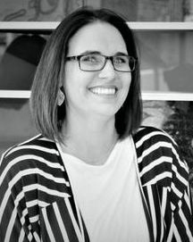
Dawn H. Clineman, M.S.
Director of Online Instruction
University of Cincinnati Online
Dawn has worked with the University of Cincinnati since 2008 and has served the university in a number of roles with the primary focus of online learning administration, design, and instruction.
Dawn has a variety of eLearning experience, and as a member of senior leadership of UC Online, she works closely with programs and faculty developing and building their online programs and classes. She has designed, developed, and facilitated faculty workshops to enhance the understanding of the design process and the pedagogical approach required for successful online teaching and learning. She also manages an instructional design team within UC Online.
Prior to working for UC, she consulted with universities across the nation and launched online programs. She supported faculty and administration in their curriculum development, their development of infrastructure, and enhancement of their business model.
Dawn received her BS degree in Social Science from Florida Atlantic University and her MS degree in Conflict Resolution from Nova Southeastern University. Dawn is passionate about bringing quality education to the online environment and ensuring the student experience is strong.

OPDC
Ohio Professional
Development Consortium
Teaching Online to Support Inclusion
Tuesday, Nov. 10, 2020

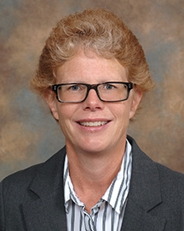
Carolyn Stoll, M.A.
Associate Director for Online Instruction
University of Cincinnati Online
Carolyn Stoll holds a Bachelor of Science in Education and a Master of Arts in English, both from Miami University of Ohio. For 18 years, she taught first year composition and technical writing at the University of Cincinnati. Prior to that, she taught middle school Language Arts and spent a short stint as a technical writer.
In 2010, Carolyn joined University of Cincinnati Information Technologies, eventually managing UCIT’s Instructional Design and Content team. In 2012, she was hired by the College of Allied Health Sciences, where she later became a Senior Instructional Designer leading the Design Team in the Center for Educational Technology and Instructional Support. Carolyn is now the Associate Director for Online Instruction with UC Online, UC’s internal Online Program Management team.
Carolyn has extensive experience teaching and developing learning content in all formats (online, hybrid, and face to face). She is a Quality Matters workshop facilitator, Coordinator, and Course Review Manager. Her research and pedagogical interests involve eLearning and Backwards Design, topics on which she has written articles and presented at both national and regional conferences.

