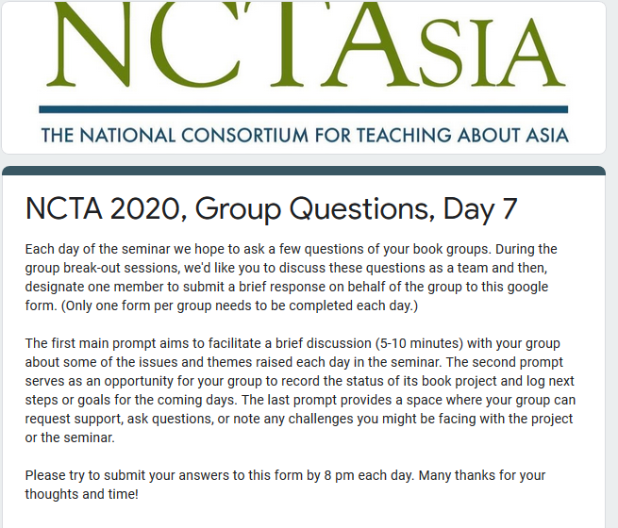What is today's date? *
MM
/
DD
/
YYYY
So that we can identify your group, please indicate your group's book title and author: *
David Clark. "Korea in World History"
Eric Cunningham. "Zen Past and Present"
David Kenley. "Modern Chinese History"
Jeffrey L. Richey. "Confucius in East Asia"
William M. Tsutsui. "Japanese Popular Culture and Globalization"
Zhiqun Zhu. "Understanding East Asia's Economic 'Miracles'"
1) Of the various topics and resources discussed today, what did your group think was most interesting or useful? Were there any unexpected or surprising themes? (If so, what were they?) How might any of the information we have covered in the seminar so far inform your teaching practice? Did you have any lingering questions you wanted to ask? *
2) The group book project deadline is tomorrow - how is your group feeling about reaching the end of the project? What final details does your group have to wrap up (if any)? Do you have any more (or new) ideas for useful criteria for a hypothetical rubric for this group project? *
3) Did you encounter any new challenges today? Are there any lingering issues that still need to be resolved? If so, how can we help? Do you have any other remarks or questions? *
Never submit passwords through Google Forms.

